*CS422: Software Analysis and Design*

**REPORT**

*Group Member:*

*- Nguyễn Minh Nhựt 1651027*

*- Diệp Gia Hân 1651077*

*- Lê Trung Kiên 1651021*

**1. Overview**

In a faraway mythical land, there are two kingdoms, each of which is rival of the other. The two have been at war for centuries. Countless young heroes fight and die for their country, even the Queens themselves.

The two kings, ‘Black King and ‘White King’ as they are called respectively, at the death of their queens, are desperate for an end of this situation, yet no one would surrender or negotiate. As a result, they declare bloody policies that cause the war to escalate, in the hope that there would be finally a winner …

“Heroes are honored, and above all, it is feats that count. Pawns with a glorious feat will be given a promotion. And those who are useless deserves a demotion” – said the first king.

The second king, adopting the first king’s policy, added:

“Pawns are the main force, yet others play vital roles in the war. Any Knights, bishops, Rooks who can kill that bastard’s queen will become MY QUEEN, and that useless new wife of mine will get kicked out to make room for you, new heroes.”

The two kings, because of the rivalry between the two kingdoms, end up adopting both policies. However, since the Black King is the first one who announced the new policy, he manages to make earlier process, and gain advantages.

Yet, one day, a man called Peter the Rule breaker claims himself king, establishes his own armed forces. To Peter the Rule Breaker, Pawns are always Pawns, negligible as usual, Heroes are heroes, no matter what they do. The only thing that matters to him is mistake.

‘A micro click, a macro hit. Undo is only for fools’ - said Peter the Rule Breaker.

The new king is warlike, challenging anyone who walks alone. Though a tyrant, he never loses to anyone dare to accept the challenge.

And there comes what we call the Chess of Chaos …

The Chess of Chaos is a chess boardgame in which a chess piece of lower rank can easily be promoted if it is used to kill that of higher rank of the opponent. However, by doing so, one chess piece of the ‘promoted rank’ will be demoted to pawn

For example, #1, if a black knight kills a white queen, the black knight will become a new black queen, yet the ‘old’ black queen will be demoted to pawn.

#2 if a black pawn kills a white bishop, the black pawn can choose to become a new knight/bishop/rook, for instance, a rook, yet the ‘old’ rook will be demoted to pawn.

For the mentioned ‘historic’ reason, black-side player is the one to move first.

There is also another mode: challenge Peter the Rule breaker - an AI agent, with all promotion and demotion discarded and ‘Undo’ feature disabled.

**2. Specific Requirements**

2.1. Functionality

2.1.1. Rooms

The system shall provide each user a room id

The system allows user to enter his or her own room to play with our AI

The system allows user to enter another person’s room

2.1.2 Self choice to play the chess of chaos

The system shall show users the rules of this game

The system shall show user all possible moves for each piece user chose

The system allows user to move a piece to a valid position

The system allows user to undo his move

The system allows user to choose another move if the chosen move is invalid

The system allows user to revert the moves

The system allows user to choose to cancel move

The system allows user to promote a piece when the rule allows

The system allows user to deny the “upgrade”

The system allows user to surrender in the middle of the game

The system allows user to make a move and kill the opponent chess piece

2.2. Usability

2.2.1. Graphical User Interface

The system shall provide a uniform look and feel between all the web pages.

The system shall provide use of icons and toolbars

The system shall provide convenient views for every player

2.2.2. Accessibility

The system shall provide handicap access

The system is in English (the most popular language)

2.3. Reliability & Availability

The system shall provide storage for more than 1000 users play at a time

The system shall provide resource for more than 1000 users play with AI at a time

The system shall provide users with stable versions with loading time for every functionality no more than 1 minutes

2.4. Performance

The product shall be based on web and have to be run from a web server

The user experience of this product shall depend on internet connections

The product should not take initial load time longer than 3s

The performance should not depend upon hardware components of the user

2.5. Security

Not applicable

2.6. Supportability

2.6.1. Configuration Management Tool

The source code developed for this system shall be maintained in configuration management tool.

2.7. Design Constraints

2.7.1. Development tools

The system shall be built using cocos2dx-js development tools that conforms to either chromium based web-browser or firefox, edge, ie,…

The system shall be built with cocos2dx-js which can also deploy cross-platform applications, web, mobiles, …

2.7.2 Web based product

There are no memory requirements

The computers must be equipped with browsers.

The product must be stored in such a way that allows the client easy access to it.

Response time for initial loading the product should take no longer than three seconds.

A general knowledge of basic computer skills is required to use the product

2.8. Online user documentation and help system requirements

The product shall acknowledge users with the game rules

The product shall instruct users to the functionalities of the provided buttons

2.9. Purchased Components

Not applicable

2.10. Interfaces

There are many types of interfaces as such supported by the Chess of Chaos software system namely: user interface, software interface, hardware interface

The protocol used shall be http

The port number used will be 8000

There shall be logical address of the system in IPv4 format.

The system can be built and run on localhost:8000 by running one of these commands at the product’s directory:

python -m SimpleHTTPServer

cocos deploy -p web

cocos deploy -p web -m release

2.10.1. User Interfaces

The user interface for the software shall be compatible to any browser such as Internet Explorer, Mozilla or Netscape Navigator by which users can access to the systems.

The user interface shall be implemented using any tool or software package like python or cocos 2djs command version etc.

2.10.2. Hardware Interfaces

Since the application must run over the internet, all the hardware shall require internet connection will be hardware interface for the system. As for e.g. Modem, WAN – LAN, Ethernet Cross-Cable.

2.10.3. Software Interfaces

The system shall communicate with the content manager to get the product specifications, offerings and promotions.

2.10.4. Communications Interfaces

Not applicable

2.11. Licensing Requirements

Not applicable

2.12. Legal, Copyright, and Other Notices

The system shall display the disclaimers, copyright, word mark, trademark and product warranties

2.13. Applicable Standards

Not applicable

2.14. Supporting Information

Use cases (below)

Structural models

Behavioral models

Non-functional requirements

* + - * Performance

Every functionalities of this system should not take more than 1 minute

* + - * Scalability

The system can handle more than 1000 user play at once due to current limitations of firebase storage and usage

The system can change the firebase package and allow larger number of users

* + - * Availability

The system is accessible for any device with internet connection

The stable version will always be available before a new version is released

* + - * Maintainability:

The system is constructed with popular programming language and design

The system must follow the specifications

* + - * Usability:

The system provides user with instruction and acknowledge user the game rules

The system provides buttons with semantic meanings, so user do not have to remember the use of any buttons

The system provides a view that is convenient for the player to move his or her pieces

* + - * Portability:

The system can easily be moved to any other popular platform like mobile or window application as it is built by cocos 2djs

Project plan

The project is divided into 2 builds:

* + - 1. Peer-to-peer application (rooms) with the chess of chaos rules
      2. AI system for Traditional Chess

**3. Use cases**

**a. Use case diagram**

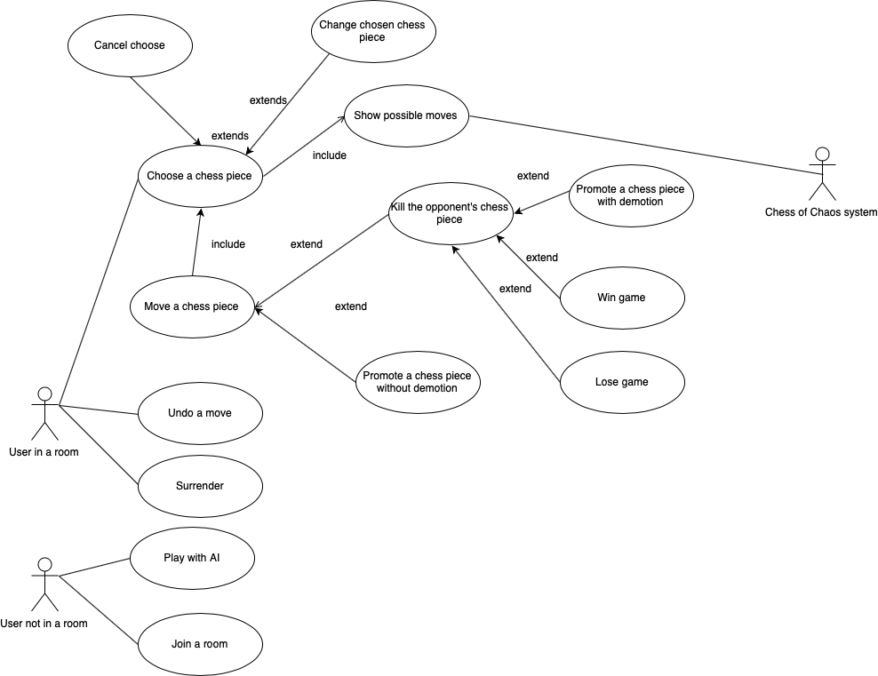

**b. Use case details**

## Use-case: Join a room

|  |  |
| --- | --- |
| Use case Name | Join a room |
| Brief description | Users join a room |
| Actors | User A and user B, both of whom has not joined a room yet |
| Basic Flow | 1. User A enters the room code of user B 2. User A click JOIN ROOM. 3. The system on BOTH users’ device switch to game screen |
| Alternative Flows | **Alternative flow 1: User join a room which is unavailable**   1. User enter a room code which is unavailable 2. User click JOIN ROOM. 3. The system show a dialog telling user that the room is unavailable. |
| Pre-conditions | User has not joined a room yet. |
| Post-conditions | User successfully join a room |

## Use-case: Play with AI – Peter the Rule Breaker

|  |  |
| --- | --- |
| Use case Name | Play with AI – Peter the Rule Breaker |
| Brief description | User will play against Peter the Rule Breaker |
| Actors | User |
| Basic Flow | 1. User enter the room code of HIS/HER OWN 2. User click JOIN ROOM. 3. The system switch to game screen of Challenge Peter mode |
| Alternative Flows |  |
| Pre-conditions | User has not joined a room yet |
| Post-conditions | User successfully join a room with the AI bot - Peter the Rule Breaker. |

## Use-case: Choose a chess piece

|  |  |
| --- | --- |
| Use case Name | Choose a chess piece |
| Brief description | User chooses a chess piece for moving |
| Actors | User who has joined a room |
| Basic Flow | 1. User click on a chess piece 2. If the chess piece is valid, i.e belongs to user, the chess piece is highlighted 3. The system will display possible moves if they exist |
| Alternative Flows | **Alternative flow 1: The chosen chess piece is not valid**   1. User chooses a chess piece which is not valid 2. The chess piece is not highlighted |
| Pre-conditions | User has joined a room. |
| Post-conditions | User successfully chooses a chess piece |

## Use-case: Move a chess piece

|  |  |
| --- | --- |
| Use case Name | Move a chess piece |
| Brief description | User performs a move, from one place to another |
| Actors | User who has joined a room |
| Basic Flow | 1. User chooses a position 2. If the position is valid, the chess piece is moved to that position |
| Alternative Flows | **Alternative flow 1: The chosen position is not valid**   1. User chooses a position which is not valid 2. The chess piece is not moved to that position, the chess piece is de-highlighted. |
| Pre-conditions | User has chosen a chess piece |
| Post-conditions | User successfully performs a chess move Both users’ screens display the right chess move |

## Use-case: Show possible moves

|  |  |
| --- | --- |
| Use case Name | Show possible moves |
| Brief description | The system shows possible moves |
| Actors | Chess of Chaos systems |
| Basic Flow | 1. User chooses a chess piece 2. If the position is valid, and thus highlighted, Chess Of Chaos system will display possible location which the chess piece can move to. |
| Alternative Flows |  |
| Pre-conditions | User has not chosen a chess piece yet |
| Post-conditions | Possible moves are shown to user correctly. |

## Use-case: Cancel Moving

|  |  |
| --- | --- |
| Use case Name | Cancel Moving |
| Brief description | User cancel moving |
| Actors | User who has joined a room |
| Basic Flow | 1. User clicks on empty space or the selected chess piece itself 2. The selected chess piece is de-highlighted |
| Alternative Flows | None |
| Pre-conditions | User has selected a chess piece |
| Post-conditions | User successfully cancels moving |

## Use-case: Change selected chess piece

|  |  |
| --- | --- |
| Use case Name | Change selected chess piece |
| Brief description | User cancel moving |
| Actors | User who has joined a room |
| Basic Flow | 1. User clicks on another chess piece 2. The previously selected chess piece is de-highlighted, the clicked chess piece is highlighted |
| Alternative Flows | None |
| Pre-conditions | User has selected a chess piece |
| Post-conditions | User successfully changes from one chess piece to another. |

## Use-case: Kill the opponent’s chess piece

|  |  |
| --- | --- |
| Use case Name | User kill the opponent’s chess piece |
| Brief description | This use case occurs when user kill the opponent’s chess piece |
| Actors | User who has joined a room |
| Basic Flow | 1. User move a chess piece to a position in which stands a chess piece of his/her opponent. 2. If the move is valid, the chess piece of his/her opponent gets discarded 3. If user’s chess piece can be promoted, the Promote Popup shows up. |
| Alternative Flows |  |
| Pre-conditions | User has successfully performed a move |
| Post-conditions | The chess piece of user’s opponent gets discarded.  Both users’ screens display this. |

## Use-case: Promote a chess piece with demotion

|  |  |
| --- | --- |
| Use case Name | Promote a chess piece with demotion |
| Brief description | This uses case occurs when a chess piece is qualified for promotion on killing |
| Actors | User who has joined a room |
| Basic Flow | 1. A Popup shows up for user to choose which to promoted to 2. User choose the chess piece to promote to. 3. The popup disappears. 4. The chess piece gets promoted. |
| Alternative Flows | **Alternative flow 1: User choose not to promote**   1. A Popup show up for user to choose which to promoted to 2. User choose not to promote. 3. The chess piece does not get promoted and no chess piece get demoted. 4. The popup disappears. |
| Pre-conditions | A chess piece gets qualified for promotion by killing a chess piece of higher rank |
| Post-conditions | If user chooses to promote, the chess piece must be promoted successfully and another chess piece of the promoted rank of user must be demoted to pawn.  Both users’ screens display this. |

## Use-case: Promote a chess piece without demotion

|  |  |
| --- | --- |
| Use case Name | Promote a chess piece |
| Brief description | This uses case happened when a pawn is qualified for promotion by moving to the other end of the chessboard |
| Actors | User who has joined a room |
| Basic Flow | 1. A Popup shows up for user to choose which to promoted to 2. User choose the chess piece to promote to. 3. The popup disappears. 4. The chess piece gets promoted. |
| Alternative Flows | **Alternative flow 1: User choose not to promote**   1. A Popup show up for user to choose which to promoted to 2. User choose not to promote. 3. The chess piece does not get promoted. 4. The popup disappears. |
| Pre-conditions | A chess piece gets qualified for promotion by moving to the other end of the chessboard |
| Post-conditions | If user chooses to promote, the chess piece must be promoted successfully .  Both users’ screens display this. |

## Use-case: Surrender

|  |  |
| --- | --- |
| Use case Name | Surrender |
| Brief description | When user forfeit |
| Actors | User |
| Basic Flow | 1. User clicks “Surrender” 2. The system shows up a dialog to confirm. 3. If user really wants to surrender, the Lose Screen shows up |
| Alternative Flows | **Alternative Flow #1: User do not want to surrender**   1. User clicks “Surrender” 2. The system shows up a dialog to confirm. 3. If user really do not want to surrender, the popup disappears |
| Pre-conditions | User has joined a room. |
| Post-conditions | If user agrees to surrender, the lose screen shows up on user’s screen and the win screen shows up on the opponent’s screen. |

## Use-case: Undo a move

|  |  |
| --- | --- |
| Use case Name | Undo a move |
| Brief description | When a user wants to undo a move |
| Actors | User A, User B |
| Basic Flow | 1. User A clicks “Revert” 2. The system on user B’s device shows up a dialog asking if he allows user A to Revert a move 3. If yes, the last move is reverted |
| Alternative Flows | User B does not agree to revert a move:   1. User A clicks “Revert” 2. The system on user B’s device shows up a dialog asking if he allows user A to Revert a move 3. User B clicks Decline 4. The last move is not reverted. |
| Pre-conditions | User A and User B are in the same room. |
| Post-conditions | If User B agrees to revert, then the system on both devices must do the revert and display accordingly. |

## Use-case: Win game

|  |  |
| --- | --- |
| Use case Name | Win game |
| Brief description | When user wins the game |
| Actors | User who has joined a room |
| Basic Flow | 1. A popup shows that user has won the game, promoting a refresh for a new game 2. User clicks on “Celebrate” to display fireworks |
| Alternative Flows |  |
| Pre-conditions | User successfully kills the opponent’s king, or the opponent surrender. |
| Post-conditions | Firework displayed correctly |

## Use-case: Lose game

|  |  |
| --- | --- |
| Use case Name | Lose game |
| Brief description | When user loses the game |
| Actors | User who has joined a room |
| Basic Flow | 1. A popup shows that user has lost the game, promoting a refresh for a new game 2. User clicks on “Mourn” to display rain of tear animation. |
| Alternative Flows |  |
| Pre-conditions | The opponent successfully kills user’s king, or user surrenders. |
| Post-conditions | Rain of tear display correctly |

**4. Class Diagram**



***Design Details***

We use Strategy design pattern for Chess Rules. By using Strategy, Promotion and Demotion becomes easier, since a chess piece’s rule can be change at runtime.

Also, using Strategy means that we can avoid unnecessary inheritance. Our Chess class, for UI displaying purpose, extends the Button class of the Cocos2dx Framework, which makes inheritance a burden on memory. Using composition over inheritance, the Chess class saves a lot of memory space.

Moreover, by using Strategy, the Queen Rule can be easily implemented by combining the Castle Rule and Bishop Rule.

As described in the next section, room is designed with Multiton Pattern.

**5. Database Design**

We make use of Firebase, which is a NoSQL database management system. The hierachy of database is simple:

Every room has an ID, which is the key for data.

In each room, there are moves, index from 0. Besides, there is revertReq – revert Request for Undo purpose.

Move request is structured as follow. chessKilledType is for reverting a move.



**6. Architecture**

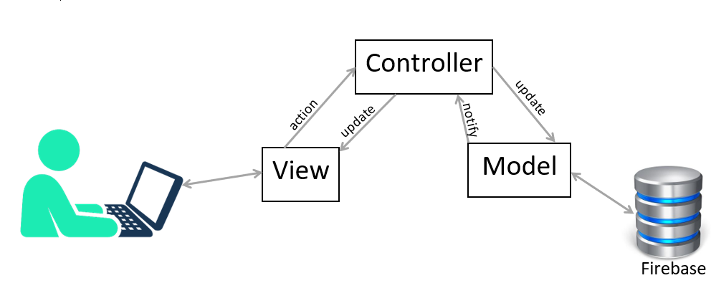

We use MVC Pattern, using Firebase as database server. The system is written in Javascript.

**7. UI Design**

1. Create/Join room page



1. Play chess screen
   1. Play screen (AI mode)



* 1. Play screen (Peer to peer)

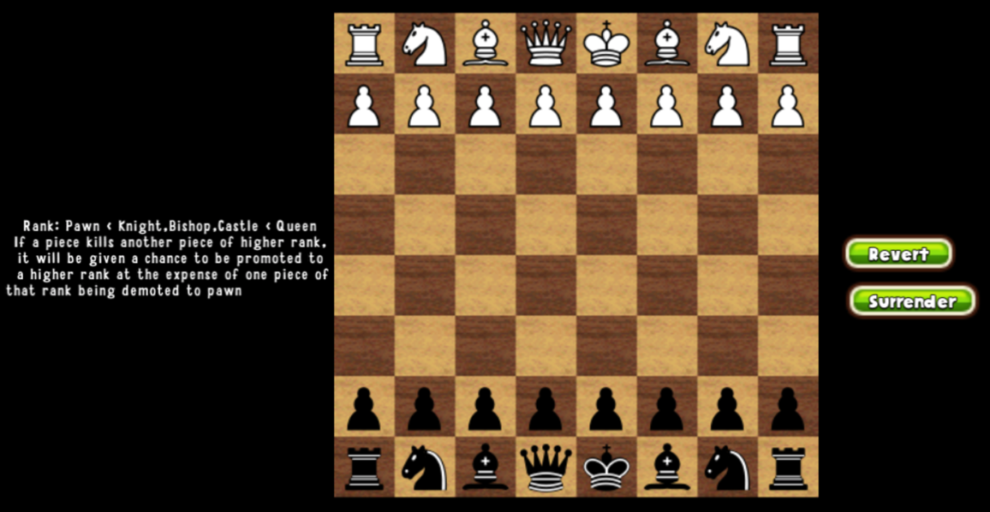

* 1. Move suggestions



1. Popups showing notifications





 

**8. Summary**

The Chess of Chaos is a simple system for playing chessboard. Simple as it may be, it provides enough features for basic users’ need, while bringing about a brand-new playstyle.

With a little twist, The Chess of Chaos can also be played on Android and iOS as native application.